TUTORIAL 8-10

**TUTORIAL 8**

**QUESTIONS**

1. It is compulsory to introduce a new relation for many-to-many relationship in ERD because the foreign keys become a primary key in the new relation.
2. Converting generalization/ specialization in ERD into relations in GRD is listed as follow.
   * Translate logical data model for target DBMS
   * Design file organization and indexes
   * Design user views
   * Design security mechanisms
   * Consider the introduction of controlled redundancy
   * Monitor and tune the operational system
3. User interface is the pages which will be shown to the client on their computer to interact with the system. System interface is designed for system integration which aims to exchange information between systems.
4. Typical menu types:
   * Menu Bar
     + Advantages: straight forwards, always in the screen, users is restricted to select actions.
     + Disadvantages: limited options, limited to one word menu.
   * Drop-down Menu
     + Advantages: named more than one word, it can do either performing action or leading to another menu.
     + Disadvantages: it does not appear every time on the menu, does not allow abbreviation.
   * Hyperlink Menu
     + Advantages: usually used for web-based system, can use one or two words.
     + Disadvantages: commonly placed along the left edge of the screen.
   * Embedded Hyperlinks
     + Advantages: makes the window more efficient because it opens a new window for an action, thus the user can return to the previous window easily.
     + Disadvantages: acts as additional information
5. Creating view about hotel numbers and hotel names

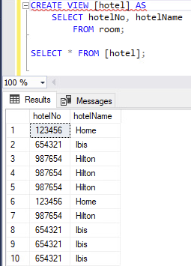

1. Insert staff number and names into guest table

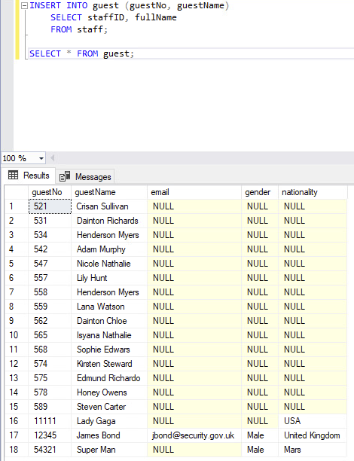

**PRACTICES**

1. View query & b. select everything

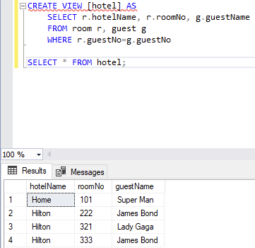

1. Drop a) view

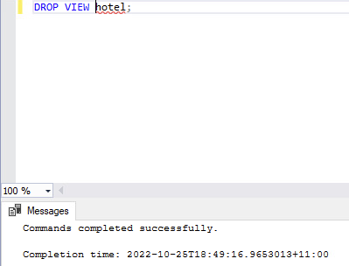

1. View query number of rooms per hotel

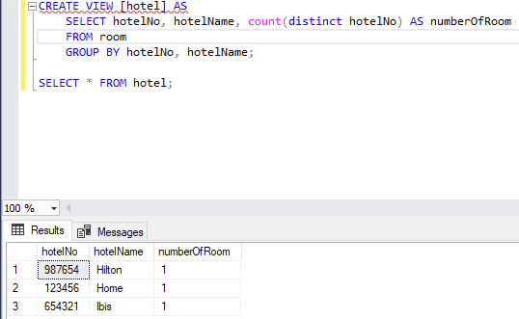

1. Pair room and type

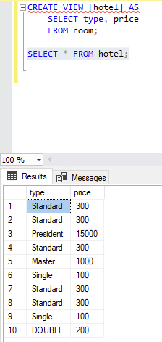

1. Distinct pair room and type

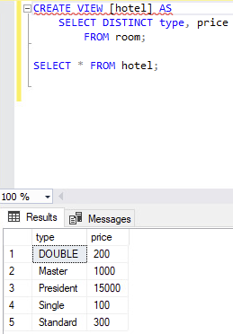

1. Index room type and price

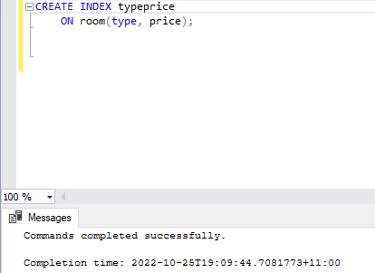

1. Drop index

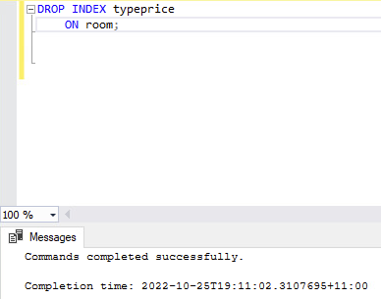

1. Index guest name

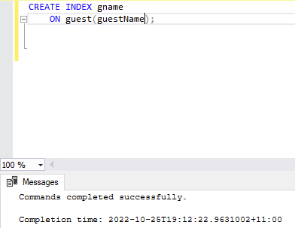

1. New table from room table

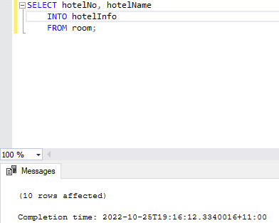

1. Insert staff numbers and names into guest table



Tutorial 9

**QUESTIONS**

1. Functional dependency is describing the attribute's meaning or semantics in case of their relationship to perform normalization. Partial functional dependency is performed when A and B are attributes of relation but the dependency still exists when some attributes of A are removed. Transitive functional dependency is happened when A, B, and C are properties of a relation, then C is transitively dependent on A via B (given that A is not functionally dependent on B or C).
2. Normalization is important for database design because the relationships get increasingly format-restricted (stronger) and less susceptible to update anomalies.
3. Typical structure arrangements are as followed.
   1. Physical structure is contained datafiles, redo log files and control files
   2. Logical structure is including schema objects, data blocks, tablespaces, extents and segments.
4. Pseudocode for sorting algorithm

For a=0 to n-1:

Smallsub=a

For b=a+1 to n-1:

If j(b) < j(smallsub)

Smallsub=j

End-if

End-for

Temp=j(a)

J(a) = J(smallsub)

J(smallsub)=Temp

End-for

**PRACTICES**

1. Declare cursor, Open cursor and generating data

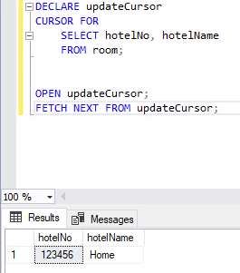

1. Release cursor

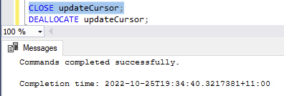

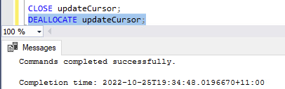

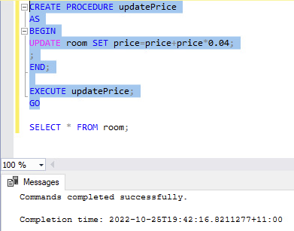

Tutorial 10

**QUESTIONS**

1. ACID properties are discussed as follows.
   1. Atomicity. This property explained that a transaction is an unbreakable unit that can either be completed entirely or not at all.
   2. Consistency. The database must be changed from one consistent state to another consistent state using a transaction.
   3. Isolation. The execution of transactions happens apart from one another. In other words, unfinished transactions shouldn't have any impacts that may be seen by subsequent transactions.
   4. Durability. An unsuccessful subsequent attempt would cause the effects of a properly completed (committed) transaction to be permanently deleted from the database.
2. Lost update problem can be solved by 2PL because because it locks all the users to update (read only) before a user who updating data commits the update.
3. Deadlock is a situation where two (or more) transactions cannot proceed because they are each waiting for the release of locks that the other is holding. It can be resolved by rolling back into one more more transactions before locked and break the deadlock.
4. The different stages for system testing are unit/module test; integration test; system test; and acceptance test (divided into alpha test and beta test). The integration test has the highest error discovery rate because it is the first testing step to combine all the units